Smart Shoebox
(Shoes care solution utilizing IoT concept)

Ko ByungHee, Kwon GyuHyeok, Kim JungHyun, Shin MinKi
Information System Department
Hanyang University Engineering School
Seoul, South Korea

Abstract—This document is about the realization of automatic remote control for shoes through IoT. We will make smart shoes cabinet that provides this kind of features with other different kind of functions.
Keywords—shoebox; shoes care; shoes rack; IoT;
Role | Name | Task description etc
User | Kwon GyuHyeok | Suggest the actual features for the Smart shoebox users can feel comfortable and interesting to use
Customer | Shin MinKi | Suggest the actual features for the Smart shoebox customers can feel comfortable and interesting to use
Software developer | Kim JungHyun | Focusing on the Technical aspects of the Smart shoebox while developing  the system
Development manager | Ko ByungHee | Consider the service side of the Smart shoebox while developing the system

Introduction
Many people experience difficulty managing their own shoes in a decent and pleasant form. Especially for the people living alone, keeping shoes clean and sweet smelling becomes a tough task to manage. When it rains, shoes get wet and dirty. Can you imagine the smell and feel of the shoe? Even worse the smell starts from the entrance to the place where you will go to sleep. This is when the actual management features are required.
What if someone or something could take care of my shoes periodically and automatically. If the shoes could be managed regularly with the aspects of humidity, temperature, and sterilization, it will save money and also provide a pleasant day with a cozy footwear. To realize the concepts of taking care of our shoes, we will develop a shoebox which manages shoes condition by controlling humidity and temperature automatically and periodically.
We are going to use Arduino to support with humidity and temperature recognition by receiving inputs through switches or sensors. Internet of Things (IoT) is also on the base of the idea. The ability to control things (especially shoes in this case) through internet is the main concept we are trying to realize. We are looking forward to create an integrated service tool such as situation awareness, automatic computing, self-growing.

Requirements

Optimizing environment function
When we wear shoes, they easily become in a state of high temperature and humidity which causes the disgusting smell, which is also the best environment for bacteria to grow. As a result, there is a need to control the condition of the cabinet keeping the shoes. To provide an optimized environment automatically and also on user’s demand is the goal.
(There is a need for defining optimized temperature and humidity)

- Temperature/Humidity control through electric fan (automatic)
The sensor receives temperature and humidity as inputs and provides an optimized environment as an output.
- Temperature/Humidity control through infrared lamp (automatic)
The sensor receives temperature and humidity as inputs and provides an optimized temperature and humidity as output.
- Drying feature (on demand)
In case the user’s shoes get wet by rain or other liquids the user can request for drying will operate (1), (2).
- Sterilization function (on demand)
In case the user feels the need for sterilization, user can request for this function, which operates (1), (2).
This function (4) differs from (3) in degrees of intensity.

- Deodorization function (on demand)
In case the user feels the need for deodorization, user can request for this function, which triggers a deodorant to shoot out.
- Deodorization function (automatic)
The user can set regular intervals to trigger the deodorant to shoot out.
- Intensity control feature
The user can choose the intensity level of (1), (2). Intensity is calculated as number between 1 to 5.

Management function
Different type of shoes requires different type of proper cares. The shoe rack needs to understand and recognize the shoes type and provide a proper management for the shoes.
(Modeling : changing ambiguous information into actual concept.)

- Shoe categorization function (bar-code scanning)
Shoe categorization through capturing the barcode for the shoes.
- Shoe categorization function (user input based)
Shoe categorization through selected category of the user.
- Shoe categorization function (captured image)
Shoe categorization through captured images of the shoes.
- Shoe categorization function (3D scanning)
Shoe categorization through 3D scanning of the shoes.
- Setting the proper management tool
After Shoe categorization, based on the shoes category, the shoe rack provides the proper setting.
(There is a need for defining proper setting for each category)
The proper setting is different in the aspect of the intensity from Optimization environment function.

Analysis function
To keep the user’s shoes in high quality we can provide an analysis for the shoes the user own.

- Absence of shoes analysis (Base information)
We have decided to analyze the absence of shoes by sensor and use it as a base information for other analysis functions.
- Durability analysis
Durability is set to decrease by the time the shoe has been put on increases.
- Life prediction analysis
Based on the information of (1), we provide the expected life of the shoes.
- Preference analysis (personal)
Based on the information of (1) for one user, we provide the preference information of the shoes. More the user put on, more the preference increases.

- Preference analysis (general)
Based on the information of (1) for a number of users, we provide the preference information of the shoes for general aspect. Using this Big data, the user can know which shoes are popular nowadays.
- Frequency analysis
Based on the information of (1), we provide the frequency information for the shoes.
- Walking habit analysis (health care)
Based on the information flatness of the shoes , we provide the information about walking habit of the users.

Recommendation function
Smart Shoes cabinet will provide recommendation information with percentages based on different kind of aspects. Of course the final choice is up to the user.

- Recommendation based on weather forecast
With weather API, the proper type of shoes is recommended.
- Recommendation based on the use of shoes
Recommending the shoes type which matches with the user’s activity.
- Recommendation based on the color of shoes
Recommending the shoes color which balances with the users clothing color.
- Notice of recommendation rate by color
Showing the recommendation rate by different colors. For example, if the shoes are recommended, a specific color will appear on the shoe rack or on the screen the user is looking at.
- Notice of recommendation rate by percentage
Showing the recommendation rate by percentage. If the shoes are recommended strongly, the percentage will appear on the shoe rack or on the screen the user is looking at.

Notification function
Shoes easily get dirty, since when people do activities, shoes are the first thing that touches the ground. The shoes cabinet will provide notification for contamination of dirt or rainwater by checking on the weight difference.

- Recognition of contamination by sensor
With the increased weight, notification is given for contamination.
- Notification for contamination by message
After the recognition of contamination, the information is notified to the user through messages.

Networking / Remote control function (UI)
Without the function for internet control, it becomes nothing more than a drying machine. With this networking function on the base, the user is able to take care of the users shoes any time, anywhere. This is the most important feature we will concentrate on. Providing the IoT environment is the main goal.

- Control function through web programming (main)
With web based program, the user can interact with the smart shoe care software and other provided information.
- Control function through mobile (sub)
With mobile application, the user can interact with the smart shoe care software and other provided information.
- Control function through embedded system (sub)
With embedded system, the user can interact with the smart shoe care software and other provided information.

III. Development environment

Choice of software development platform
- Platform used for developing
We will use both Windows and MAC OS . Since Windows is the most popular OS used worldwide and MAC OS is the second most popular OS leaving out all the other versions of Windows. We thought MAC OS X will become more popular.

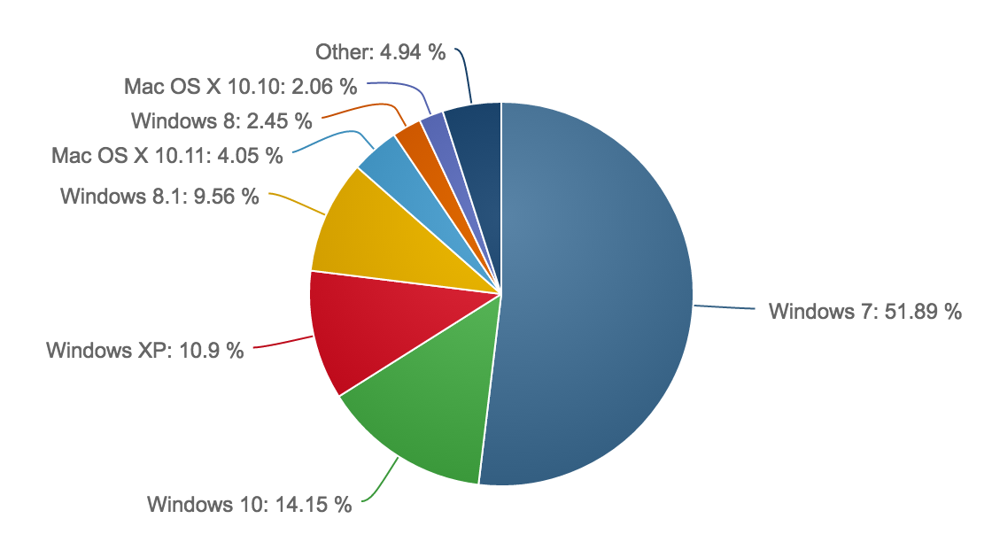
- Market share reports (January, 2016 to March, 2016)
http://www.netmarketshare.com/

- Programming language used for developing

Programming language | Reason
Arduino
mysql
Ruby
HTML5&CSS3

- Provide a cost estimation for your built.(including any purchase of software/hardware)

Device | Price
Arduino uno
Arduino wido
Temperature humidity sensor
Weight sensor
Fan(actuator)
lamp

Source Tree(v1.8.3) – version control software
Git(v2.8.1) – project control software
GitHub – remote repository(www.github.com)
우리 사이트 언급
Sublime3(3103) – text editor software
MAC OS X El Capitan
Windows 7
Arduino1.6.8.v

Software in use
Any existing software or algorithm in use? (doing a similar task as your proposal; provide a proper reference if there is any)
LG trome styler
Shinko Technos for temperature and humidity control

- Task distribution
Name | Task description
Kwon GyuHyeok | arduino
Shin MinKi | mysql
Kim JungHyun | Wireless fidelity
Ko ByungHee | Ruby(php 대신)

IV. Specifications

Optimizing environment function
- Temperature/Humidity control through electric fan (automatic)
The sensor receives temperature and humidity as inputs and provides an optimized environment as an output.

- Temperature/Humidity control through infrared lamp (automatic)
The sensor receives temperature and humidity as inputs and provides an optimized temperature and humidity as output.
- Drying feature (on demand)
In case the user’s shoes get wet by rain or other liquids the user can request for drying will operate (1), (2).
- Sterilization function (on demand)
In case the user feels the need for sterilization, user can request for this function, which operates (1), (2).
This function (4) differs from (3) in degrees of intensity.
- Deodorization function (on demand)
In case the user feels the need for deodorization, user can request for this function, which triggers a deodorant to shoot out.
- Deodorization function (automatic)
The user can set regular intervals to trigger the deodorant to shoot out.
- Intensity control feature
The user can choose the intensity level of (1), (2). Intensity is calculated as number between 1 to 5.

Management function

Different type of shoes requires different type of proper cares. The shoe rack needs to understand and recognize the shoes type and provide a proper management for the shoes.
(Modeling : changing ambiguous information into actual concept.)

- Shoe categorization function (bar-code scanning)
Shoe categorization through capturing the barcode for the shoes.
- Shoe categorization function (user input based)
Shoe categorization through selected category of the user.
- Shoe categorization function (captured image)
Shoe categorization through captured images of the shoes.
- Shoe categorization function (3D scanning)
Shoe categorization through 3D scanning of the shoes.
- Setting the proper management tool
After Shoe categorization, based on the shoes category, the shoe rack provides the proper setting.
(There is a need for defining proper setting for each category)
The proper setting is different in the aspect of the intensity from Optimization environment function.

Analysis function

To keep the user’s shoes in high quality we can provide an analysis for the shoes the user own.

- Absence of shoes analysis (Base information)
We have decided to analyze the absence of shoes by sensor and use it as a base information for other analysis functions.
- Durability analysis
Durability is set to decrease by the time the shoe has been put on increases.
- Life prediction analysis
Based on the information of (1), we provide the expected life of the shoes.
- Preference analysis (personal)
Based on the information of (1) for one user, we provide the preference information of the shoes. More the user put on, more the preference increases.
- Preference analysis (general)
Based on the information of (1) for a number of users, we provide the preference information of the shoes for general aspect. Using this Big data, the user can know which shoes are popular nowadays.
- Frequency analysis
Based on the information of (1), we provide the frequency information for the shoes.
- Walking habit analysis (health care)
Based on the information flatness of the shoes , we provide the information about walking habit of the users.

Recommendation function

Smart Shoes cabinet will provide recommendation information with percentages based on different kind of aspects. Of course the final choice is up to the user.

- Recommendation based on weather forecast
With weather API, the proper type of shoes is recommended.
- Recommendation based on the use of shoes
Recommending the shoes type which matches with the user’s activity.
- Recommendation based on the color of shoes
Recommending the shoes color which balances with the users clothing color.
- Notice of recommendation rate by color
Showing the recommendation rate by different colors. For example, if the shoes are recommended, a specific color will appear on the shoe rack or on the screen the user is looking at.
- Notice of recommendation rate by percentage
Showing the recommendation rate by percentage. If the shoes are recommended strongly, the percentage will appear on the shoe rack or on the screen the user is looking at.

Notification function

Shoes easily get dirty, since when people do activities, shoes are the first thing that touches the ground. The shoes cabinet will provide notification for contamination of dirt or rainwater by checking on the weight difference.

- Recognition of contamination by sensor
With the increased weight, notification is given for contamination.
- Notification for contamination by message
After the recognition of contamination, the information is notified to the user through messages.

Networking / Remote control function (UI)

Without the function for internet control, it becomes nothing more than a drying machine. With this networking function on the base, the user is able to take care of the users shoes any time, anywhere. This is the most important feature we will concentrate on. Providing the IoT environment is the main goal.

- Control function through web programming (main)
With web based program, the user can interact with the smart shoe care software and other provided information.
- Control function through mobile (sub)
With mobile application, the user can interact with the smart shoe care software and other provided information.
- Control function through embedded system (sub)
With embedded system, the user can interact with the smart shoe care software and other provided information.

